A2 & X2 Ultra Safety Guide
Comtrade System Integration – AI/Robotics Team

Contents
A2 & X2 Ultra Safety Guide 1
1. A2 Ultra: 2
1.1 A2 Ultra – Activation: 2
1.2 A2 Ultra – Setup: 4
1.3 A2 Ultra – Deactivation: 4
1.4 A2 Ultra – Charging and Battery Changing: 5
1.5 A2 Ultra – General Safety Tips: 6
2. X2 Ultra: 7
2.1 X2 Ultra – Activation: 7
2.2 X2 Ultra – Setup: 7
2.3 X2 Ultra – Deactivation: 8
2.4 X2 Ultra – Charging and Changing Battery: 8
2.5 X2 Ultra – General Safety Tips: 8

A2 Ultra:
The A2 Ultra Humanoid Robot weighs approximately 70kg. As such, it is important to be safe and careful above all when handling the A2 Ultra. Below is a guide on how to safely activate, deactivate, and handle the A2 Ultra.

1.1 A2 Ultra – Activation:
The A2 Ultra has a small panel beneath its battery space, which holds the Power button. The button will glow green when the robot has been activated, and have no light when the robot is off. In order to activate the robot, you must lift the panel first by gently pushing at it, which will activate the release mechanism. Pull the panel up to reveal the button (Image on next page):

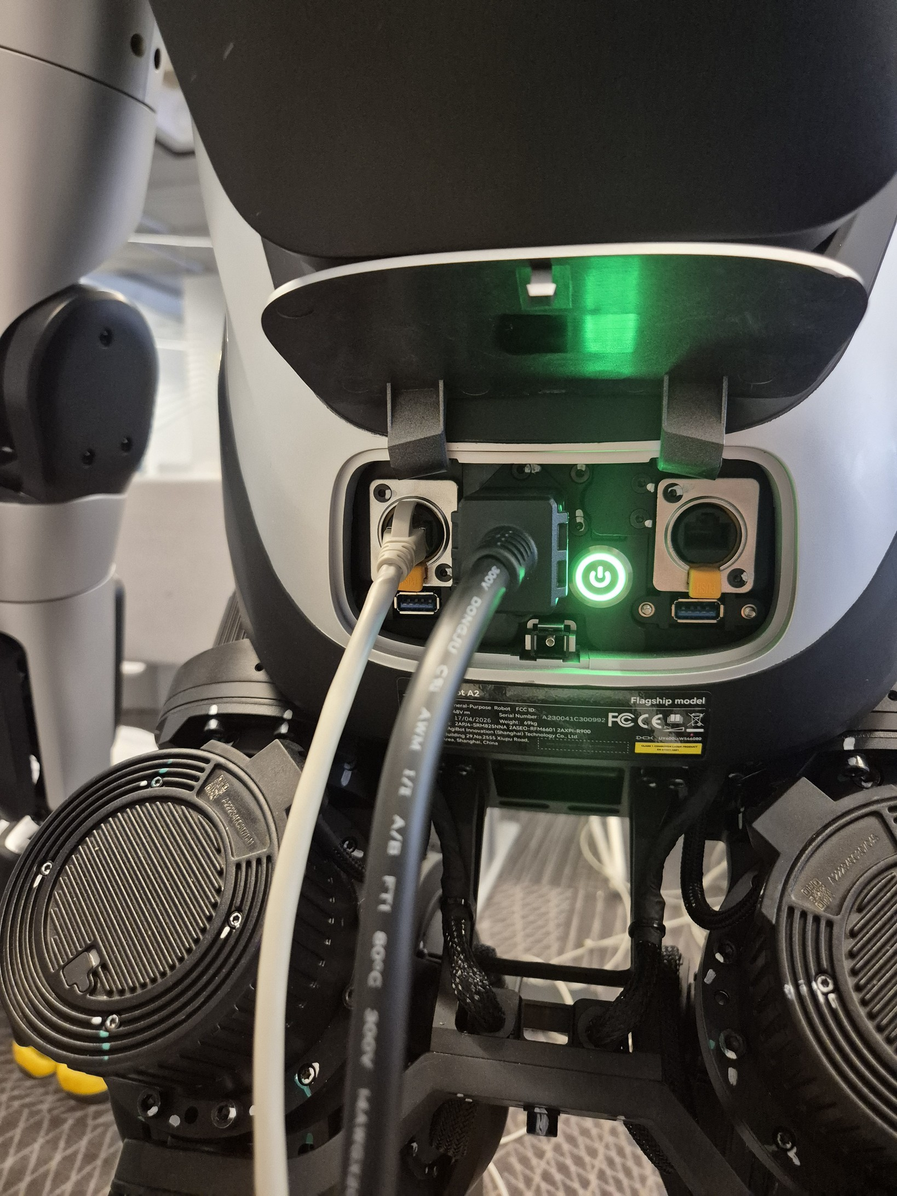

To activate the robot, a user must press the button once quickly, release, and then hold the button until the green light activates. Upon this, a startup sequence will be started, where the robot will initialize. The robot’s other light indicators will activate, and a distinctive “beep” sound will be heard. The robot will also start moving its wrist and neck joints.
When activating the robot, it is crucial that you keep your hand away from any motors at all times. While the robot will typically only move the wrist and neck joints during the startup sequence, it is entirely possible that it will also move its arm joints to the default position if they are not already

there. Another important note is that during the startup sequence, the wrist and neck movement is static, and as such the LiDAR and Motor Controller based reaction will not be active, meaning the robot can hurt you if you are too close.
During the startup sequence, the robot should be supported by some object to keep it in place. In a general case, this will be the gantry that holds it upright, but in case of emergency, the robot can also be placed on a chair or other object designed for sitting.

1.2 A2 Ultra – Setup:
The A2 Ultra uses the tablet provided by Agibot for setup start. The robot does not need to be set up to be programmed, but it can be useful for quick setups, like giving the robot a face, or general activation of movement (again, this can be done in code, but simpler to do via tablet). The Mentors will be in charge of the tablet and setup in this case, but for safety, be mindful that the A2 will need space around it to be clear so that it can complete setup. It will move its legs at this time, and can hurt someone, so keep a comfortable distance away from it at all times during setup.

1.3 A2 Ultra – Deactivation:
To deactivate the A2 Ultra, you will use the same button and pressing combination as used on the activation step. The key here is to be mindful of what state the robot is in at any given time, whether its hanging, or standing on its own. Deactivation will kill all motors and stop the robot from standing upright on its own or balancing. If the robot is not hanging at any point during this time, it will fall. Be mindful when turning the robot off about the location of any hands, fingers, or other body parts. Keep all body parts away from any part of the robot except the button, as it can lead to injury.
The safest way to deactivate the robot is as follows:
- Set the robot into hanging mode via the tablet.
- Lift the robot up using the gantry so that it is no longer touching the ground at all.
- Get behind the robot and press the deactivation button quickly once and then hold.
- The robot should then shut off.

1.4 A2 Ultra – Charging and Battery Changing:
The A2 Ultra has a battery life of between 1.5-3 hours depending on how much activity it is doing and what kind of activity (physical movements drain more battery). While it is easiest to just keep the robot plugged into its charging cable at all times, this may not always be possible. In this event, you will need to change the battery. The robot’s battery can be changed while the robot is still in the same session as before, but it must be performed fast.

To replace the battery for further use outside the charger, use the following steps:
  - Move the robot back to the gantry and attach it to the shoulder hooks (ignore this step if the robot is already attached).
  - Open up the panel which has the power button (this is where the cable will go).
  - Take the charging cable (make sure it is plugged in → Light indicator will let you know if it is getting power from the outlet) and plug it into the robot’s cable input slot.
KEEP ALL BODY PARTS AWAY FROM MOTORS AT THIS TIME.
  - Wait a few seconds, the robot’s head side-lights should turn green. This indicates that charging has started.
  - Grab the battery by the handle, and with another hand, push and hold the button on top of the battery.
  - Pull the battery firmly but not aggressively upwards. It should slot out relatively easily.
  - The robot should at this point turn red on the head side-lights. This indicates that the “battery” is low.
  - You will then need to quickly grab the second battery and plug it into the battery slot. It should slot in easily.
  - The light should then turn green, indicating that the robot is charging and battery is slotted in correctly.
The power cable should be able to supply the robot with the required power required to maintain it active, but please slot the battery back in as quickly as possible to avoid any errors or issues.

1.5 A2 Ultra – General Safety Tips:
The A2 is a fairly heavy machine, weighing roughly 70kg (as mentioned 100s of times before in all the documentation). As such, please be mindful of this at all times. It might look clumsy or harmless, but it can hurt someone who isn’t careful around it, even with the integrated safety systems. When moving the robot, please give the mentors notice, and have them keep overwatch over any actions the robot performs so they may interfere.
The A2 has an idle animation that it will go into after ~10 seconds of idleness. In this case, it will stand in place, and rotate its waist and head to try and mimic human idleness. This animation will not act like others, where a close proximity object will stop the animation. As such, please keep mindfulness that this animation will trigger at any point if the robot is idle and not doing movements. It can be deactivated using the “ARM” button in the Navigation setting, which will entirely ignore the animation, and keep the robot in a stand-still state, where it will only balance when needed. This is the safest way to get around the potential dangers of the animation (for further details on the ARM function, consult the section on it in the navigation guide (Supervisor version) of the documentation).
Do not, at any point, unless a mentor is notified and present, stick fingers, hands, or any body parts inside of the robot, between joints, or in any area. The robot’s movements can close in on those parts, and since the robot cannot feel or see that you may have placed fingers inside of it, it may injure you. If anything gets stuck inside of the robot (which shouldn’t happen in the first place), please consult a mentor instead of trying to fix it yourselves.

2. X2 Ultra:
The X2 Ultra weighs approximately 40kg. While it is small, it can pack a punch, and cause dangerous situations if not handled with care. Below is some tips for safety when working with the X2 Ultra.

2.1 X2 Ultra – Activation:
The X2 Ultra can be activated on the backside of it, where the battery is. To activate it, you must press the button on the battery once quickly, and then hold it. The quick press should have some of the panels light up in it (If <4 lit up, not 100% battery). Once you hold the button down, the 4 lights should light up from first to last one by one. Once you light up all 4 lights, you may release the button, and the robot will turn on a few seconds later.
During this time it will be limp and not able to move at all. The greatest concern for this case is if it isn’t propped up well on something, it may fall. If it is on the designated chair we brought to the hackathon, it will be fine.

2.2 X2 Ultra – Setup:
Once the X2 is turned on. It will need a few seconds for it to initialize systems within itself. During this time, do not press any buttons. Once it declares it is ready (vocally), users may begin working with it.
To stand up the robot from a sitting position, simply connect the provided PS5 controller. After you connect, you can press the left up button and the right circle button to activate the standing preparation mode. Have one person behind the robot for this, holding it by the back handle, to avoid robot falling. Pressing the left up button and right square button will activate the stand action, which will allow the robot to stand and be controlled via the controller. The left stick is for forward/back and left/right movement, and the right stick is for turning.
To set the robot back into the sitting, you can change it into the damping mode, which will slowly lower the robot, and slowly disable the joints. To do this, hold the triggers, and the left side tiny button (demonstrated in video). Once it is in damping mode, place the robot on a chair (ideally the designated chair), and then you can place it in zero-torque mode, where the motors will fully turn off. To do this, hold the two triggers, and the left tiny button. Do not set to zero torque mode as the robot will fall much more powerfully, which can lead to injury.

2.3 X2 Ultra – Deactivation:
To turn off the robot, make sure it is sitting down. The process for deactivating is the same as the activation, except the visual que will go from 4 to 0 instead of 0 to 4 lights on.

2.4 X2 Ultra – Charging and Changing Battery:
The battery can be removed by pulling it out. The charger is magnetic and can be attached to the robot during charging. You cannot change the battery while the robot is active, so changing it means resetting the session.

2.5 X2 Ultra – General Safety Tips:
The X2 also has a state for when it is idle. It doesn’t move, but it instead snaps into place. When it is in this position, and it makes a move, the robot will snap. Make sure people are not near the robot when it does this, to avoid the motors snapping on someone.
The robot’s LiDAR sensor is also only 120°, which means it cannot see entirely around it. As such, when it performs animations, it is much more dangerous, and as such people should be more careful around it.

